**Week 10 – Programming Assignment:**

**Add Custom Functionality of Your Own Choice**

for

Master of Science

Information and Communications Technology

Stephanie Torres

University of Denver University College

June 5, 2020

Faculty: Steven Russell, Ph.D.

Director: Michael S. Batty, Ph.D., PMP

Dean: Michael J. McGuire, MLS

1. I first added the ability for users to add a new topic. I started by creating a new file “forms.py”:

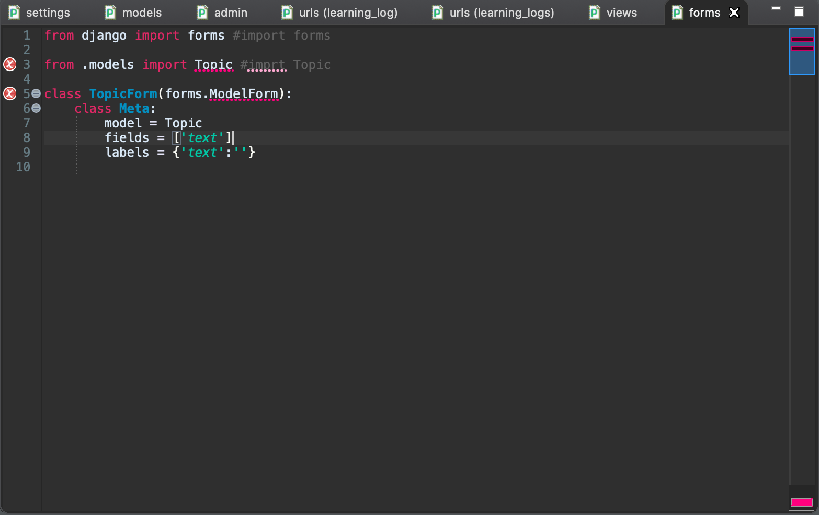

1. I added the new_topic URL to the url.py file.

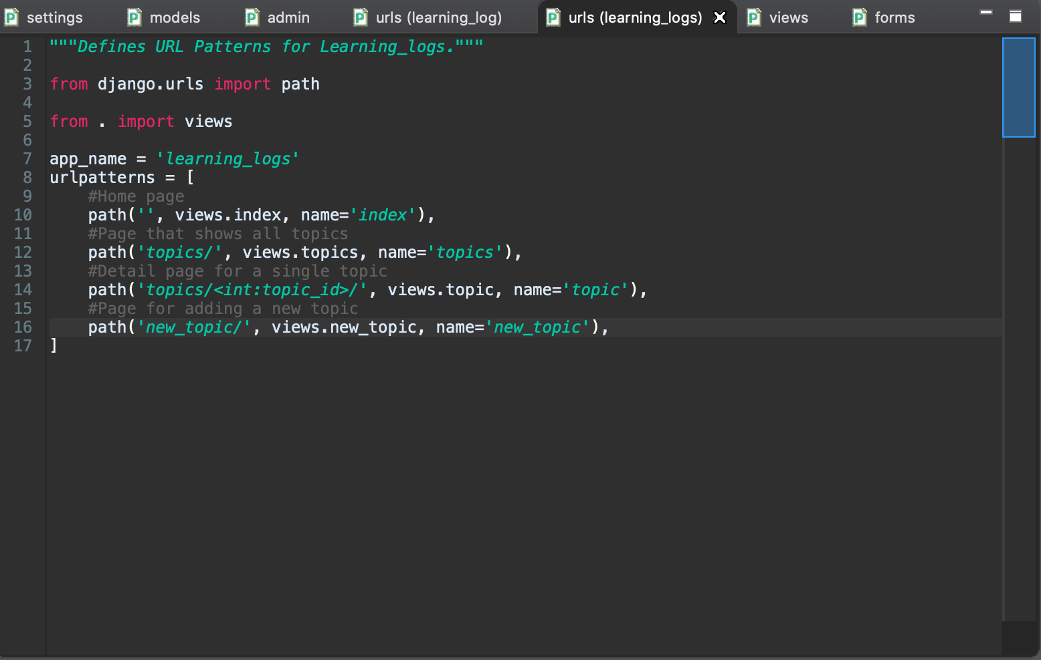

1. I then created the new_topic() View function

1. I then created a new_topic template:

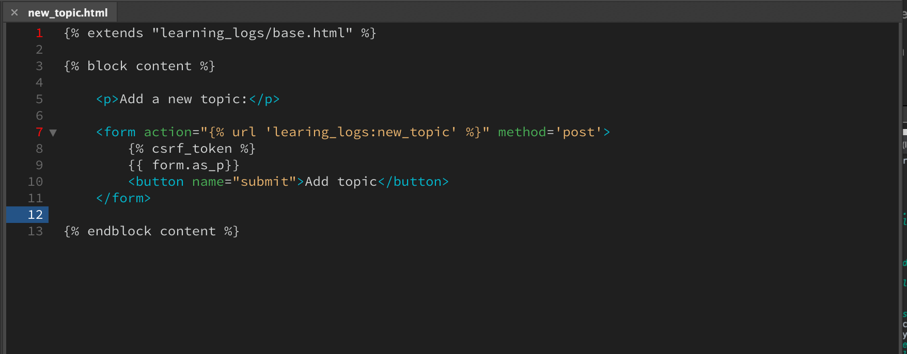

1. I then linked to the new_topic page:

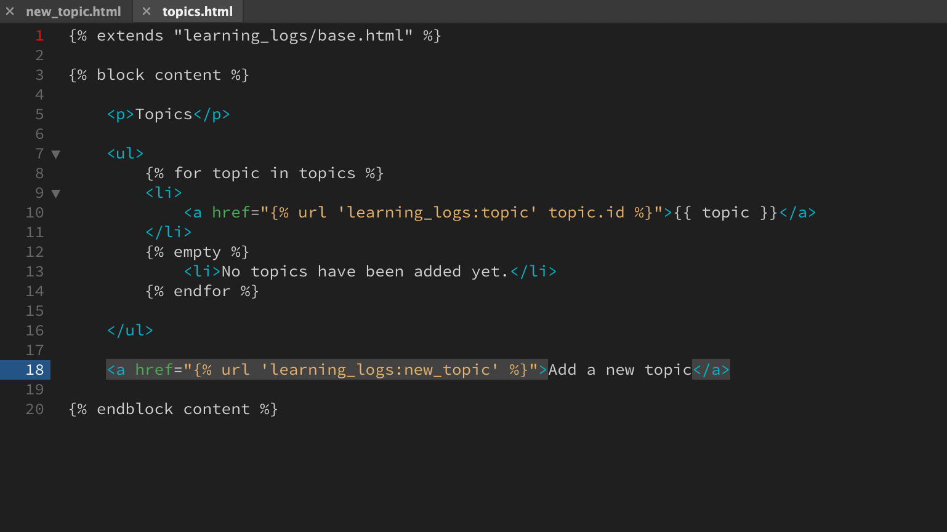

1. I then tried running the server and got an error. I had missed the colon in “if form.is_valid():” in views.py. I then got the following error:

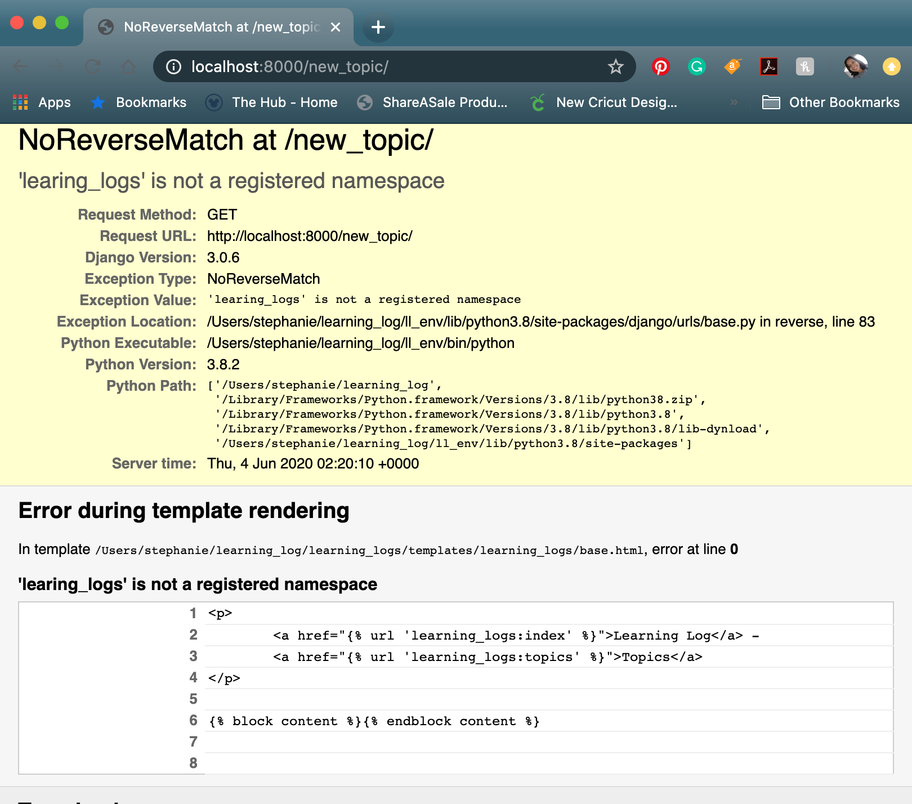

1. I traced it back to a typo in the new_topic.html, I was missing an N in ‘Learning_Logs’ and that resolved the issue.

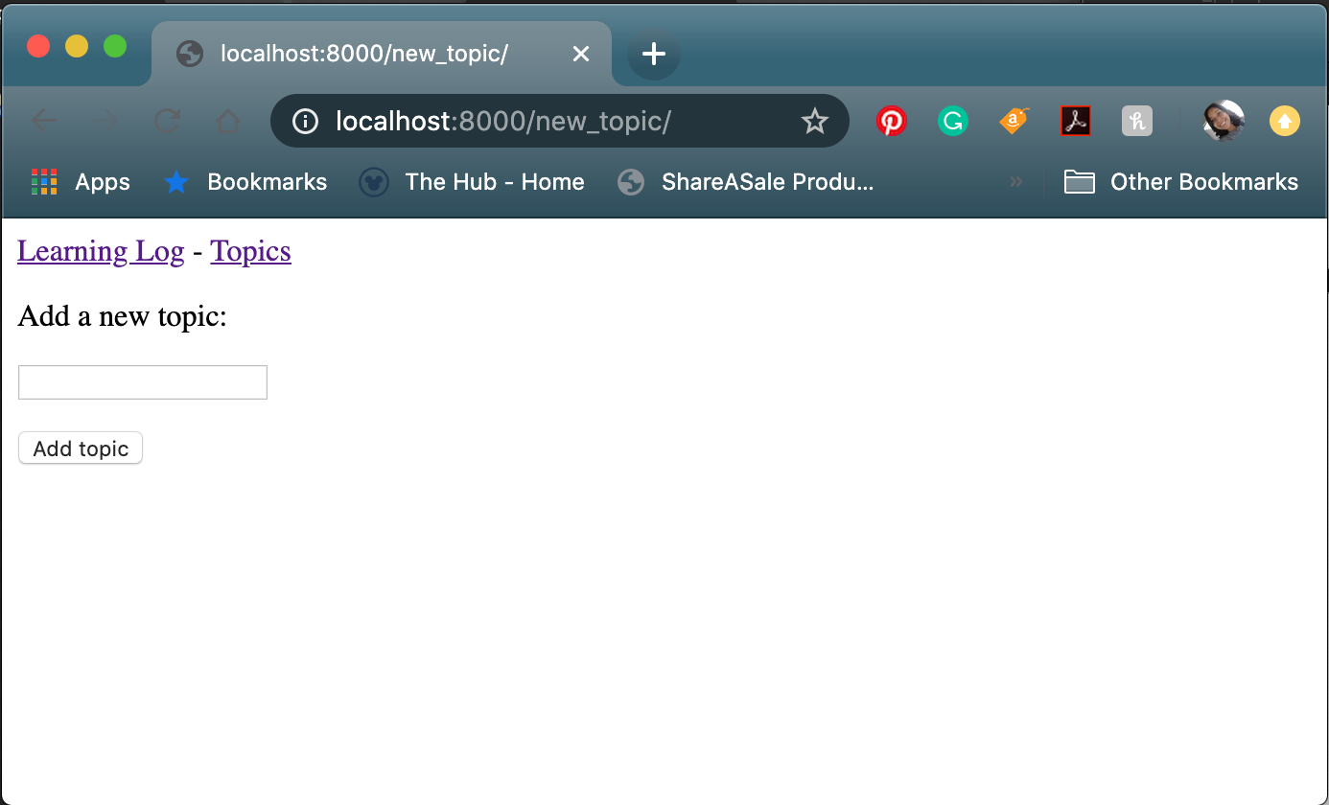

1. I then went on to allow the user to add new entries too. I first created a form associated with the Entry model in the form.py file.

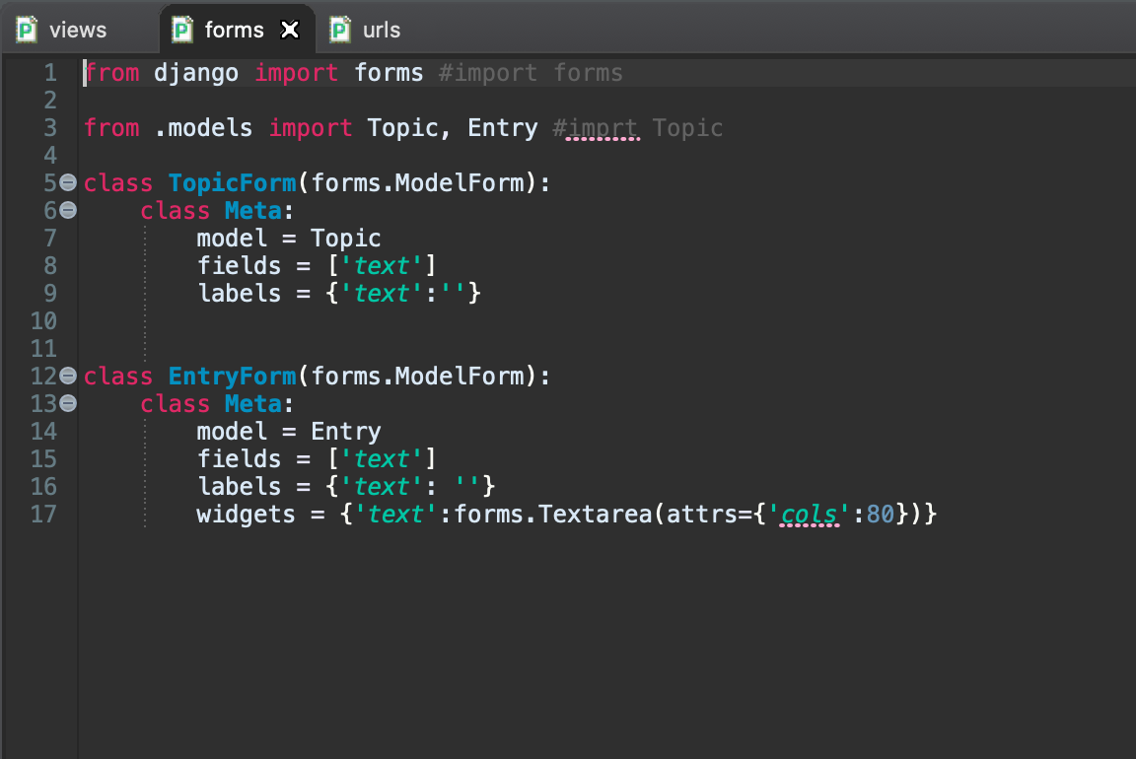

1. I then altered the urls.py file to associate new entries with a particular topic.

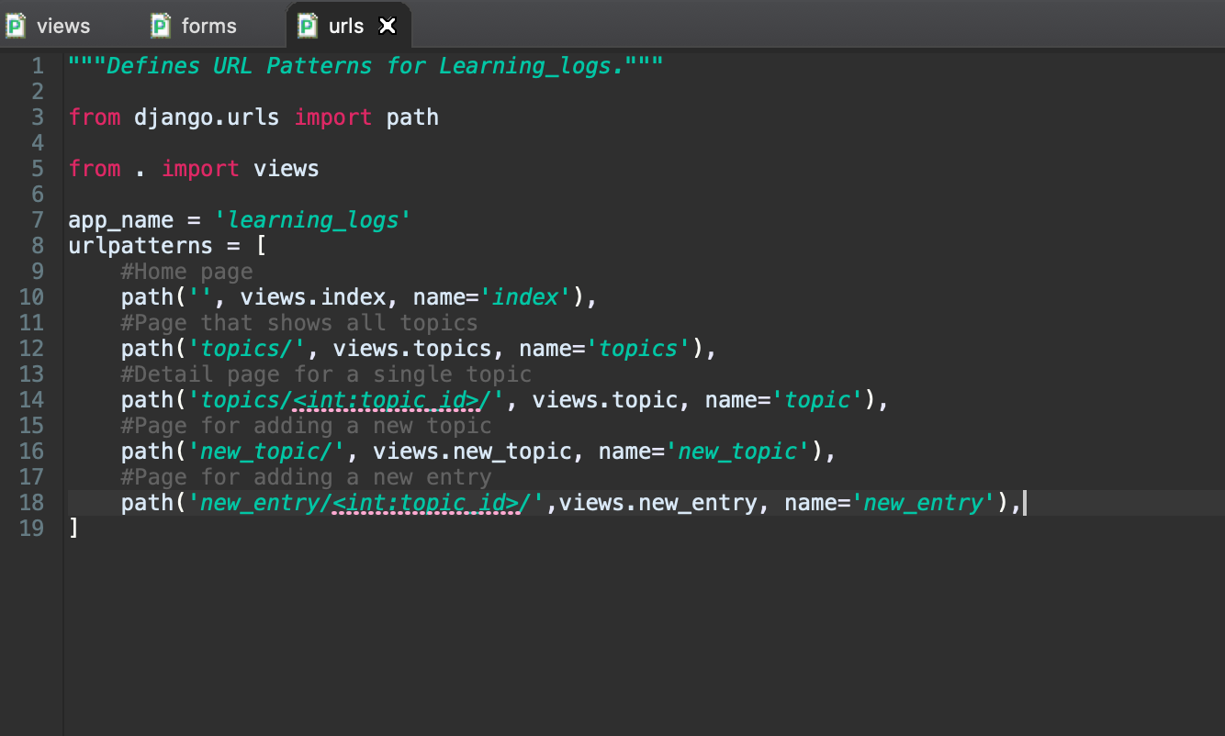

1. I then created the new_entry view function in the views.py file.

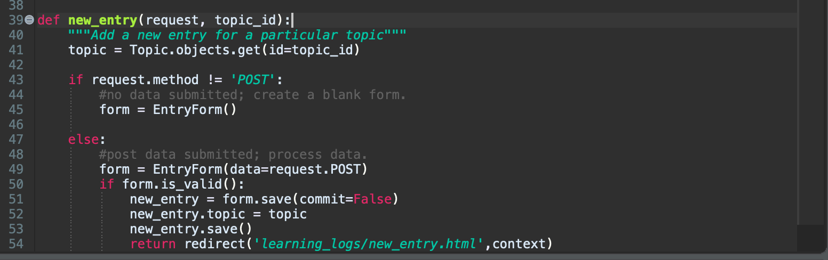

1. I then create a new_entry template as new_entry.html

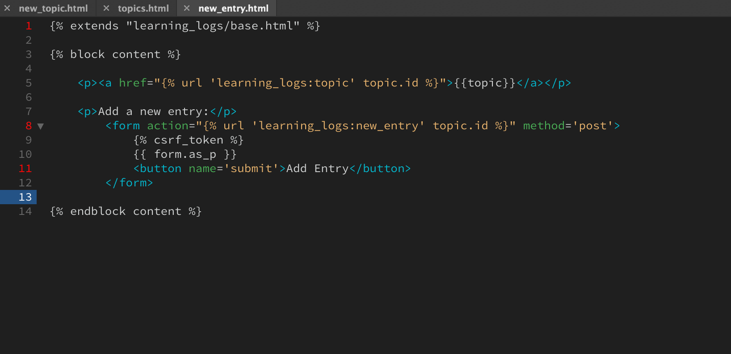

1. I then linked the topic.html to the new_entry.html page

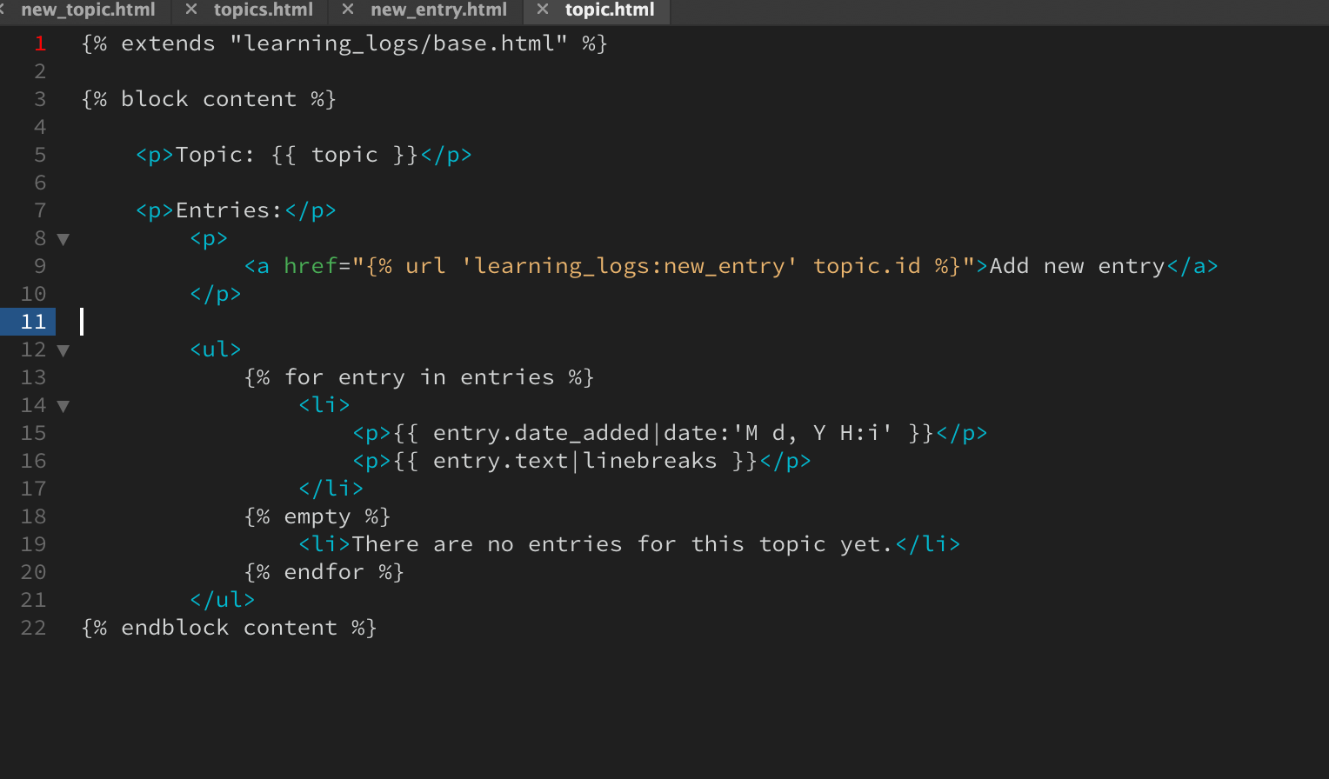

1. The form then worked

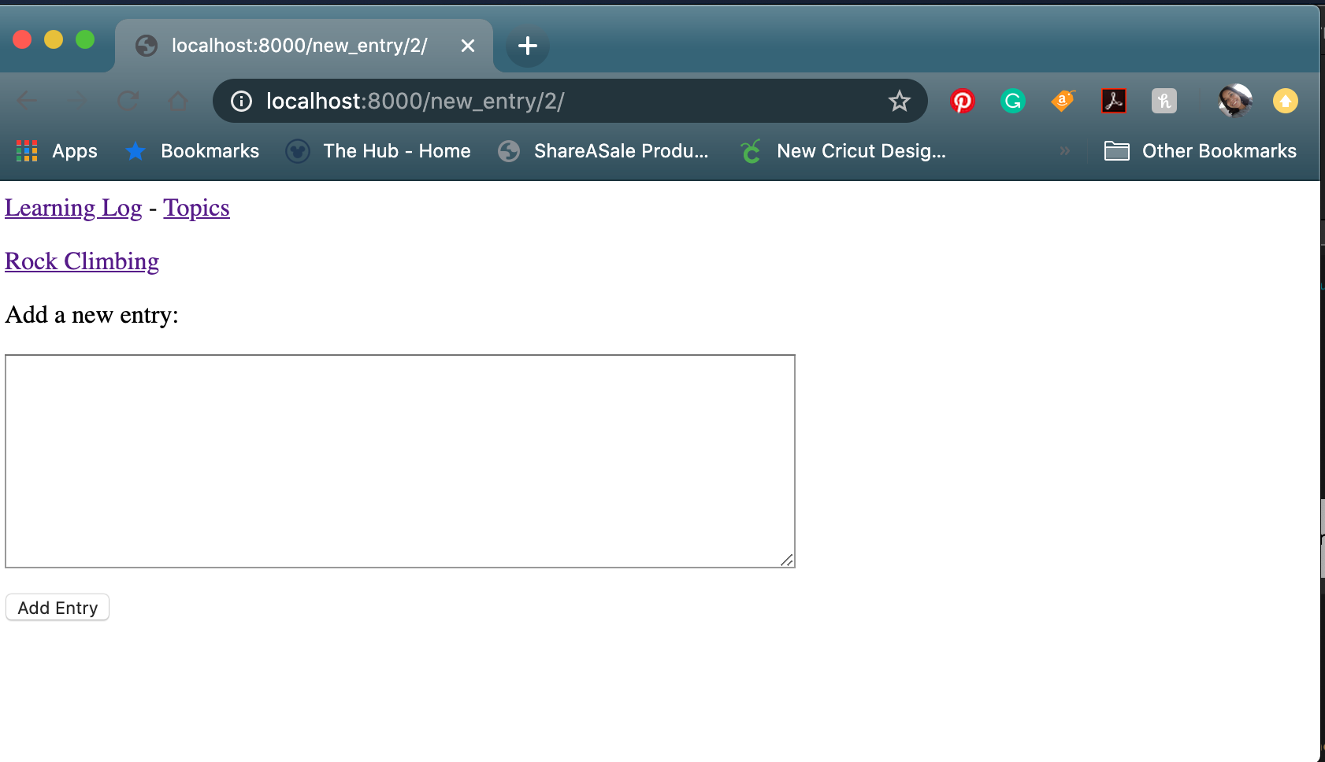

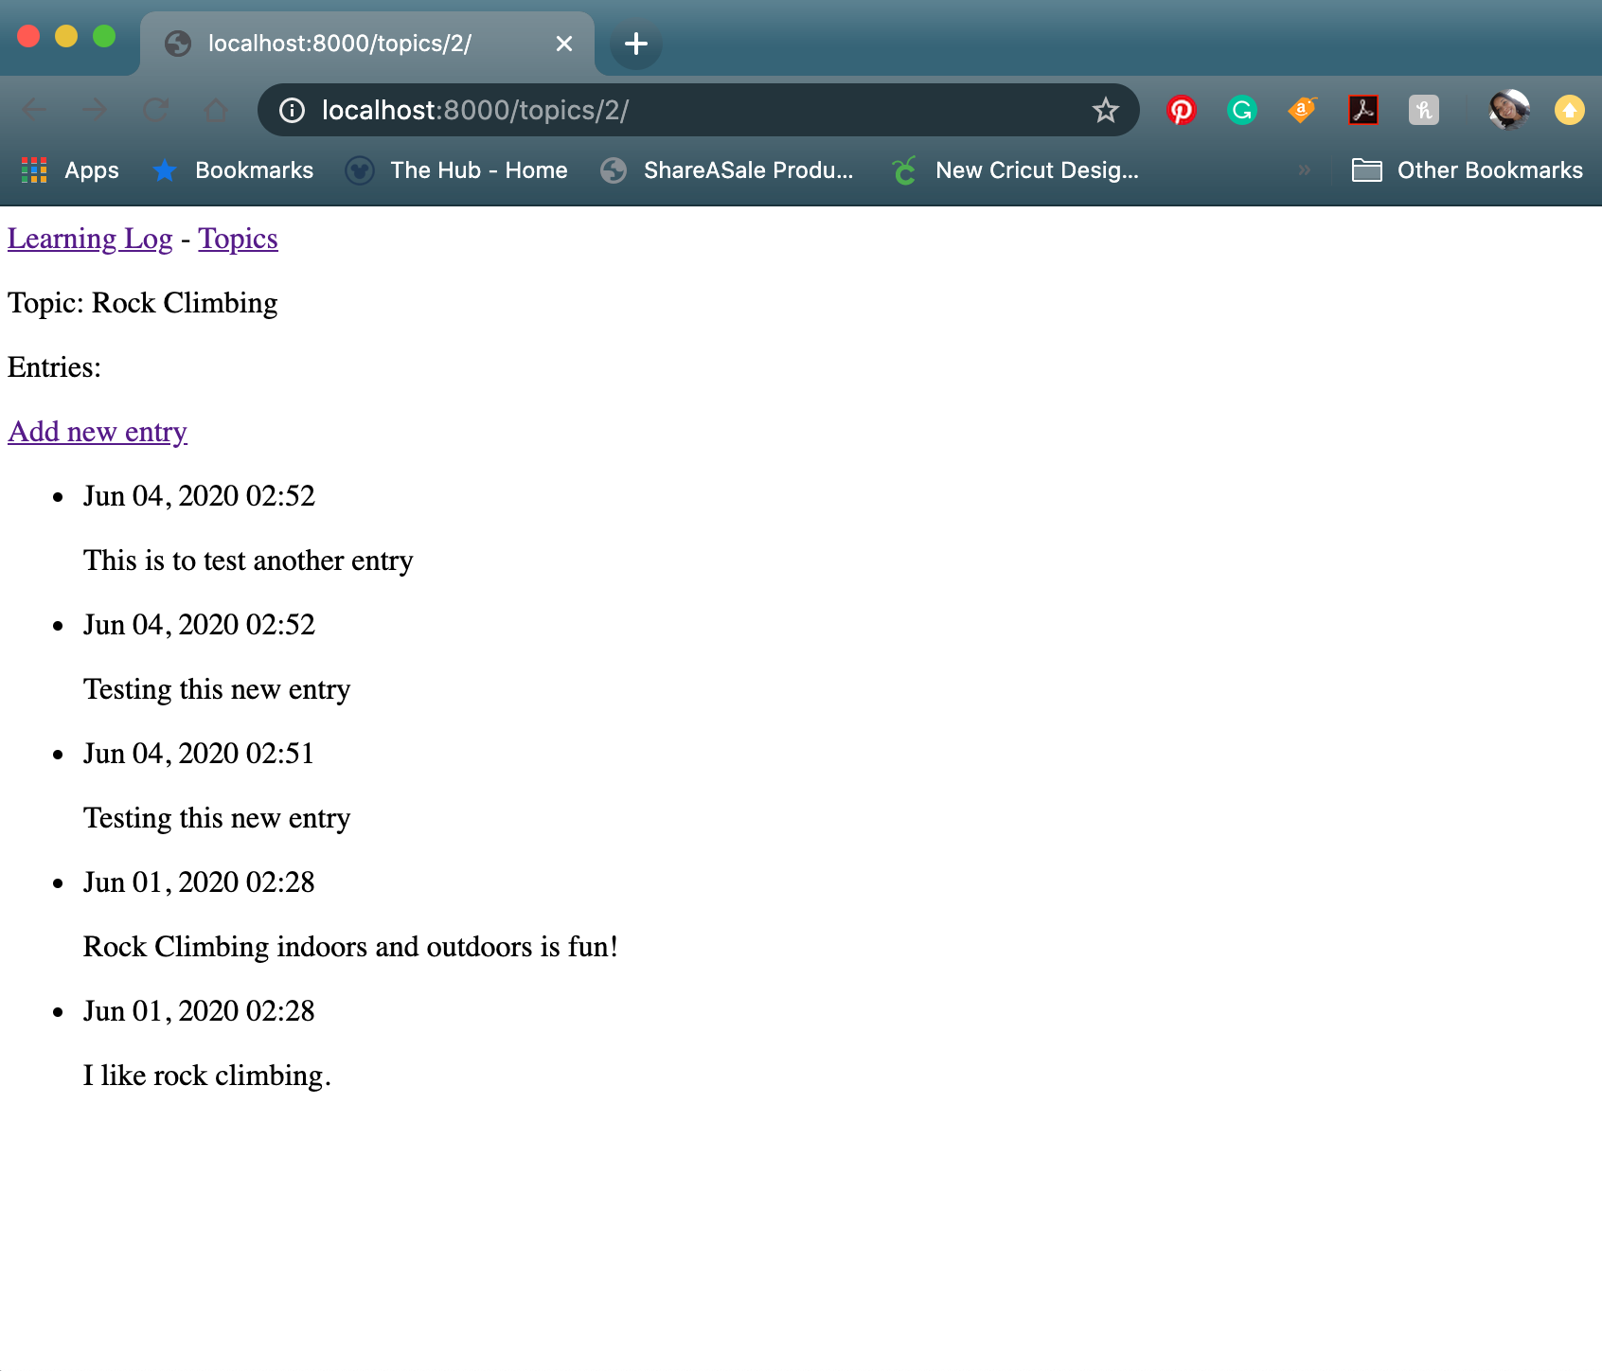

1. I then adding the ability for users to edit the entries they have added. I first altered the urls.py page.

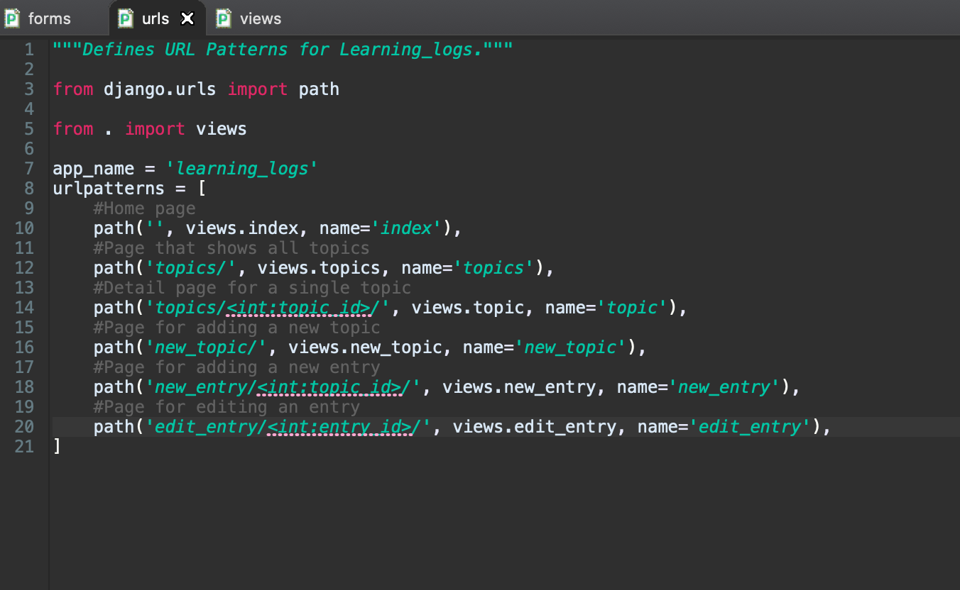

1. I then made the edit_entry() view function in the views.py file.

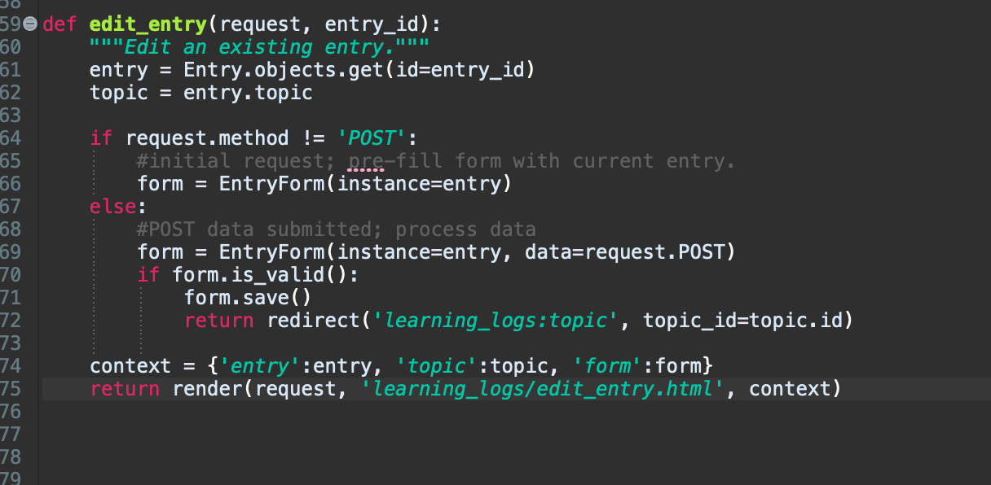

1. I then created an edit_entry.html template.

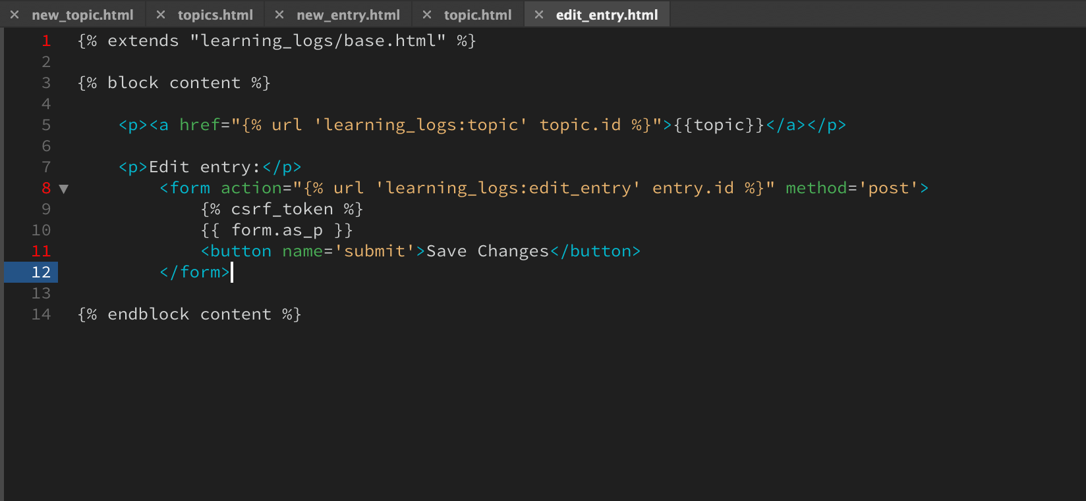

1. I then linked the edit_entry page to the topic page.

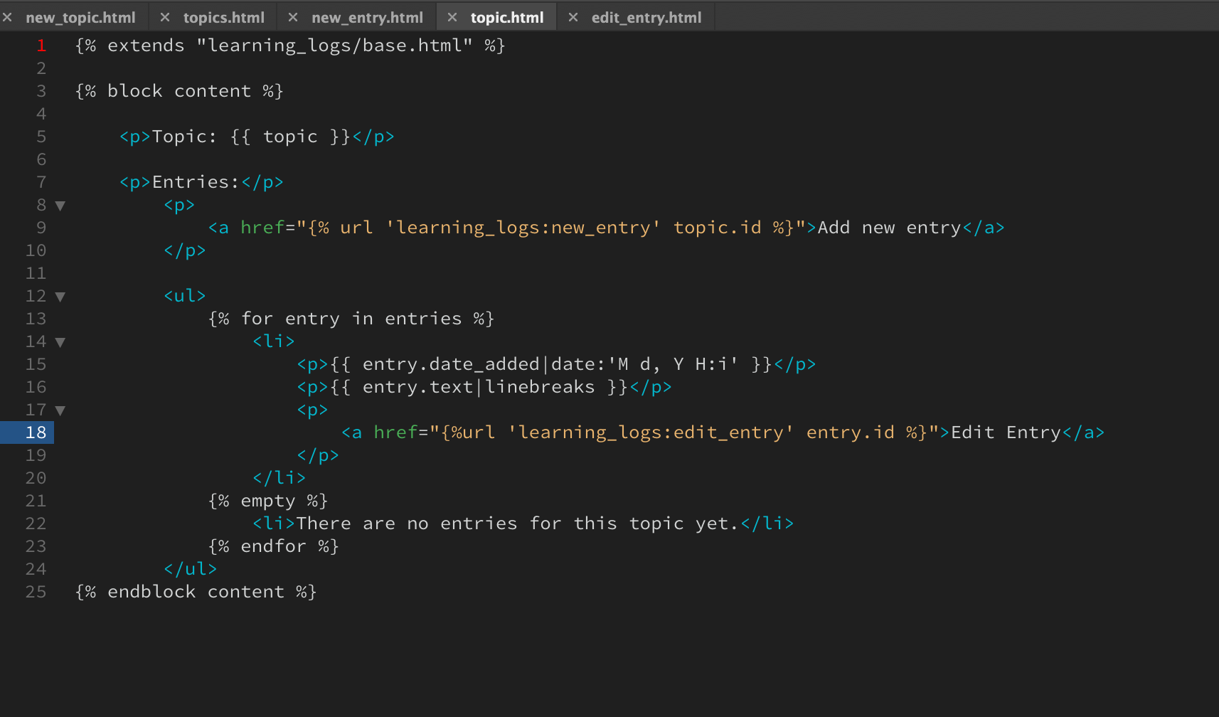

1. I then checked that this function worked.

